CSE 301 : COMPUTER NETWORKS LAB RECORD



Experiment 1: Using Wireshark for Network Traffic Analysis

Aim:
To capture real-time network traffic using Wireshark and analyze the packet contents for protocol, source, destination, and data transfer details.

About:
Wireshark is a packet analyzer tool that captures live network packets and displays them in detail. This helps understand how data is transmitted, how protocols interact, and detect unusual network activity.
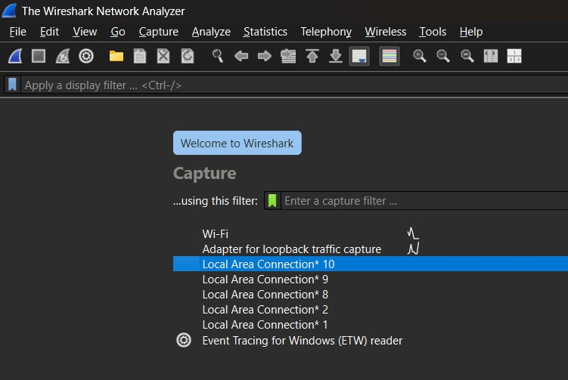
Output:

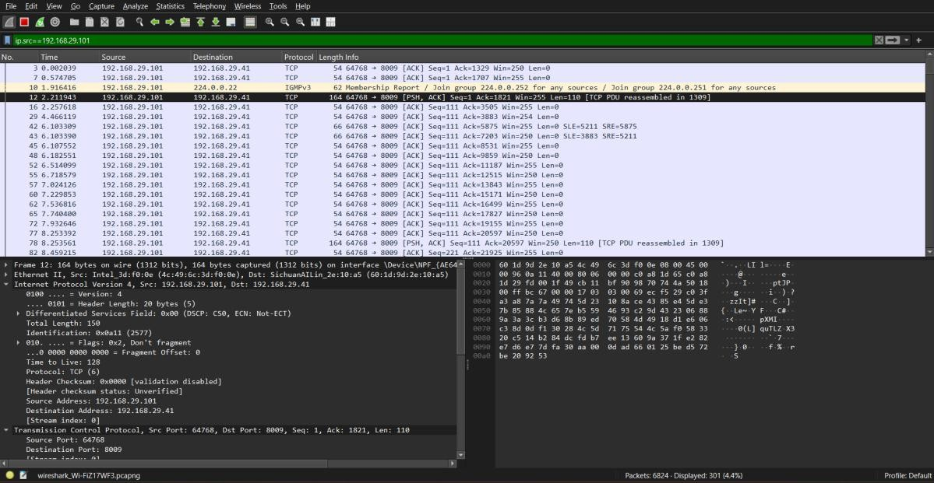
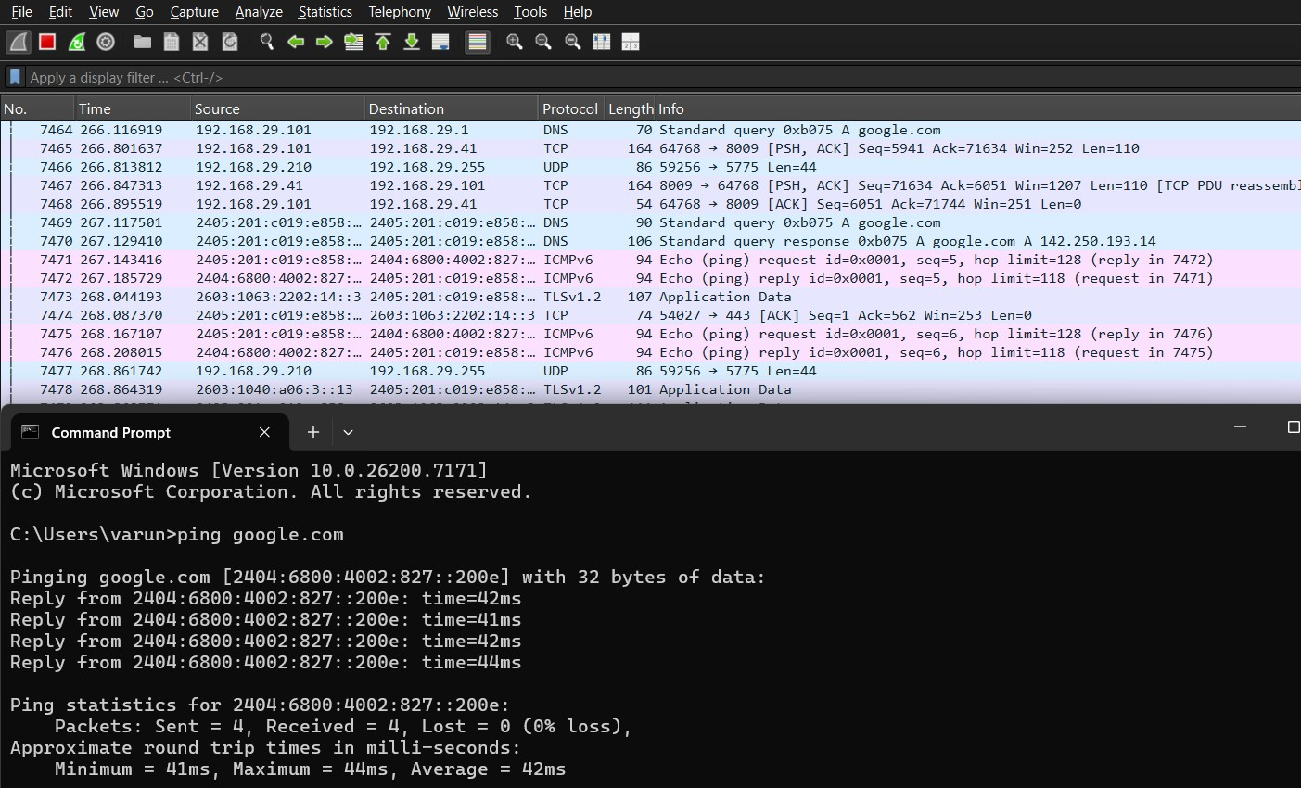

Experiment 2: Error Detection using CRC Algorithm

Aim:
To simulate the Cyclic Redundancy Check (CRC) algorithm for detecting errors in transmitted messages.

About:
CRC is an error-detecting technique that generates a checksum using polynomial division. The receiver recalculates CRC and compares it to detect transmission errors.

Code:
import java.util.*;

public class CRC {

// XOR operation (ignoring first bit)
static String xor(String a, String b) { StringBuilder result = new StringBuilder(); for (int i = 1; i < b.length(); i++) {
result.append(a.charAt(i) == b.charAt(i) ? '0' : '1');
}
return result.toString();
}
// Perform Mod-2 division
static String mod2div(String dividend, String divisor) {

int pick = divisor.length();
String tmp = dividend.substring(0, pick);

while (pick < dividend.length()) {
if (tmp.charAt(0) == '1')
tmp = xor(divisor, tmp) + dividend.charAt(pick);
else
tmp = xor("0".repeat(pick), tmp) + dividend.charAt(pick); pick++;
}

// Last division step
if (tmp.charAt(0) == '1') tmp = xor(divisor, tmp);
else
tmp = xor("0".repeat(pick), tmp);

return tmp; // This is the remainder (FCS)
}

// Sender side: create codeword by appending FCS
static String generateCodeword(String data, String generator) {
int n = generator.length() - 1;

String appendedData = data + "0".repeat(n); // step: append zeros String fcs = mod2div(appendedData, generator); // compute remainder

return data + fcs; // final transmitted frame (k + n bits)
}
// Receiver side: check remainder
static boolean checkReceived(String received, String generator) {

String remainder = mod2div(received, generator);
return remainder.equals("0".repeat(generator.length() - 1));
}

public static void main(String[] args) { Scanner sc = new Scanner(System.in);

// Example generator polynomial (you can change if needed) String generator = "1101";

System.out.print("Enter data bits (k-bit frame): "); String data = sc.nextLine();

// Sender
String codeword = generateCodeword(data, generator); System.out.println("Transmitted Frame (k+n bits): " + codeword);

// Receiver
System.out.print("Enter received frame: "); String received = sc.nextLine();

if (checkReceived(received, generator)) System.out.println("No Error Detected.");
else
System.out.println("Error Detected.");
}
}
Output:
1.
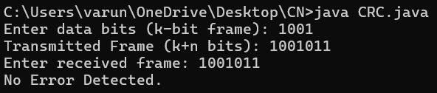
2.
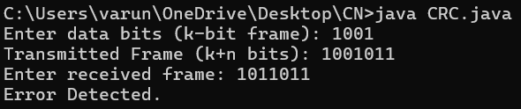

3.
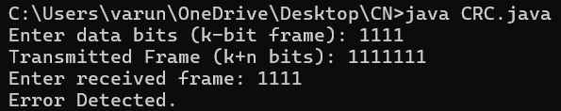

Experiment 3: Error Correction using Hamming Code

Aim:
To write a program that implements Hamming Code for single-bit error detection and correction.

About:
Hamming Code adds redundancy bits to transmitted data for error correction. It identifies and corrects single-bit errors without retransmission.

Code:
#include <stdio.h> #include <math.h>
/*Function to calculate parity bits*/
void generateHammingCode(int dataBits[], int m, int hammingCode[]) {
int r = 0, i, j, k;
/*Find number of redundant bits*/ while ((1 << r) < (m + r + 1)) { r++;
}
int n = m + r; // total length
/* Initialize hamming code with -1 (to mark parity positions)*/ k = 0;
for (i = 1; i <= n; i++) {
if ((i & (i - 1)) == 0) { // parity positions: powers of 2 hammingCode[i] = -1;
} else {
hammingCode[i] = dataBits[k++];
}
}
/* Calculate parity bits*/ for (i = 0; i < r; i++) { int pos = 1 << i;
int parity = 0;
for (j = pos; j <= n; j++) {
if (j & pos) {
if (hammingCode[j] != -1) { parity ^= hammingCode[j];
}
}
}
hammingCode[pos] = parity;
}
printf("\nGenerated Hamming Codeword: ");
for (i = n; i >= 1; i--) { printf("%d", hammingCode[i]);
}
printf("\n");
}
/* Function to detect and correct error*/
void detectAndCorrect(int hammingCode[], int n) {
int r = log2(n) + 1, i, j;

int errorPos = 0;
/* Check parity bits*/ for (i = 0; i < r; i++) { int pos = 1 << i;
int parity = 0;
for (j = pos; j <= n; j++) {

if (j & pos) {
parity ^= hammingCode[j];
}
}
if (parity != 0) { errorPos += pos;
}
}
if (errorPos == 0) { printf("\nNo error detected.\n");
} else {
printf("\nError detected at position: %d\n", errorPos);
/* Correct the error*/ hammingCode[errorPos] ^= 1; printf("Corrected Hamming Codeword: "); for (i = n; i >= 1; i--) { printf("%d", hammingCode[i]);
}
printf("\n");
}
}
int main() {
int m, i, n;
int dataBits[20], hammingCode[50]; printf("Enter number of data bits: "); scanf("%d", &m);
printf("Enter data bits (LSB first): ");
for (i = 0; i < m; i++) { scanf("%d", &dataBits[i]);
}
/* Generate Hamming Code*/ generateHammingCode(dataBits, m, hammingCode);
/* Calculate total length (data + parity bits)*/
int r = 0;

while ((1 << r) < (m + r + 1)) r++; n = m + r;
/* Introduce error manually*/
int pos;
printf("\nEnter error position (0 for no error): "); scanf("%d", &pos);
if (pos != 0 && pos <= n) {
hammingCode[pos] ^= 1; // flip bit at error position printf("Erroneous Hamming Codeword: ");
for (i = n; i >= 1; i--) { printf("%d", hammingCode[i]);
}
printf("\n");
}
/* Detect and correct*/ detectAndCorrect(hammingCode, n); return 0;
}

Output:
1.
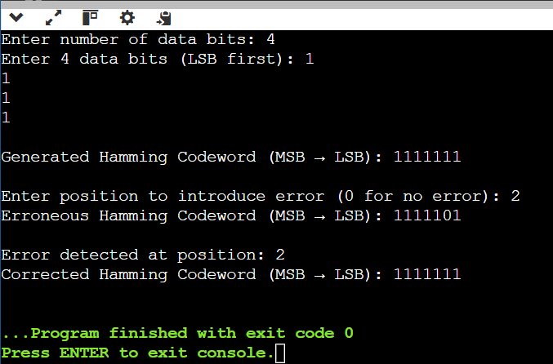
2.
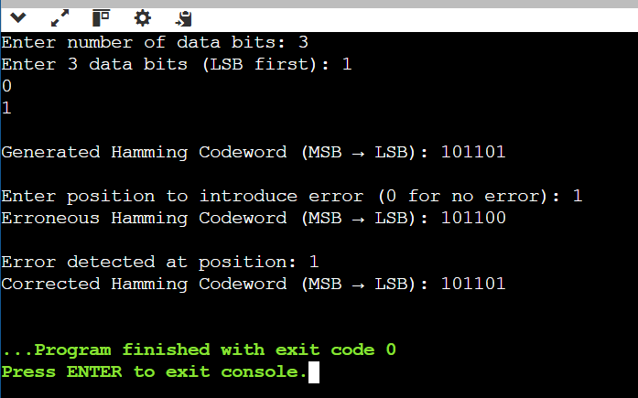

3.
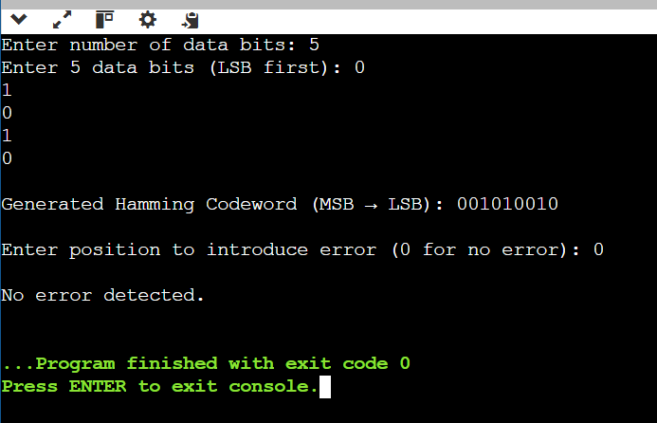

Experiment 4: Stop and Wait Protocol

Aim:
To implement a 1-bit Stop and Wait protocol at the Data Link Layer.

About:
In Stop and Wait ARQ, the sender transmits one frame at a time and waits for acknowledgment before sending the next frame, ensuring reliable communication.

Code:
StopAndWaitServer.java
import java.io.*;
import java.net.*;
import java.util.Scanner;

public class StopAndWaitServer {
public static void main(String[] args) throws Exception { ServerSocket ss = new ServerSocket(8080); System.out.println("Server waiting for client...");

Socket socket = ss.accept(); System.out.println("Client connected.");

DataOutputStream out = new DataOutputStream(socket.getOutputStream()); DataInputStream in = new DataInputStream(socket.getInputStream()); Scanner sc = new Scanner(System.in);

System.out.print("Enter total number of frames to send: ");
int totalFrames = sc.nextInt();
int seq = 0; // 1-bit sequence number
for (int frame = 0; frame < totalFrames;) { System.out.println("Sending frame " + frame + " with seq=" + seq);
out.writeInt(frame); out.writeInt(seq); out.flush();
int ackSeq = in.readInt(); // receive ACK seq number System.out.println("Received ACK for seq=" + ackSeq);

if (ackSeq == seq) {
System.out.println("ACK OK. Moving to next frame.\n"); seq = 1 - seq; // alternate sequence number
frame++; // send next frame
} else {
System.out.println("Wrong ACK! Resending frame...\n");
// automatically retries (frame not incremented)
}
}

System.out.println("All frames sent successfully.");

out.close();
in.close(); socket.close(); ss.close();

}
}

StopAndWaitClient.java
import java.io.*;
import java.net.*;

public class StopAndWaitClient {
public static void main(String[] args) throws Exception {

Socket socket = new Socket("localhost", 8080); System.out.println("Connected to server.");

DataInputStream in = new DataInputStream(socket.getInputStream()); DataOutputStream out = new DataOutputStream(socket.getOutputStream());

int expectedSeq = 0;

while (true) {
try {
int frame = in.readInt(); int seq = in.readInt();

System.out.println("Received frame " + frame + " with seq=" + seq);

if (seq == expectedSeq) {
System.out.println("Frame " + frame + " is correct.");
out.writeInt(seq); // ACK
expectedSeq = 1 - expectedSeq; // alternate seq number
} else {
System.out.println("Frame out of order! Sending previous ACK.");
out.writeInt(1 - expectedSeq); // send previous ACK
}

System.out.println();

} catch (EOFException e) { System.out.println("Transmission complete."); break;
}
}

in.close();
out.close(); socket.close();
}
}

Output:

1.
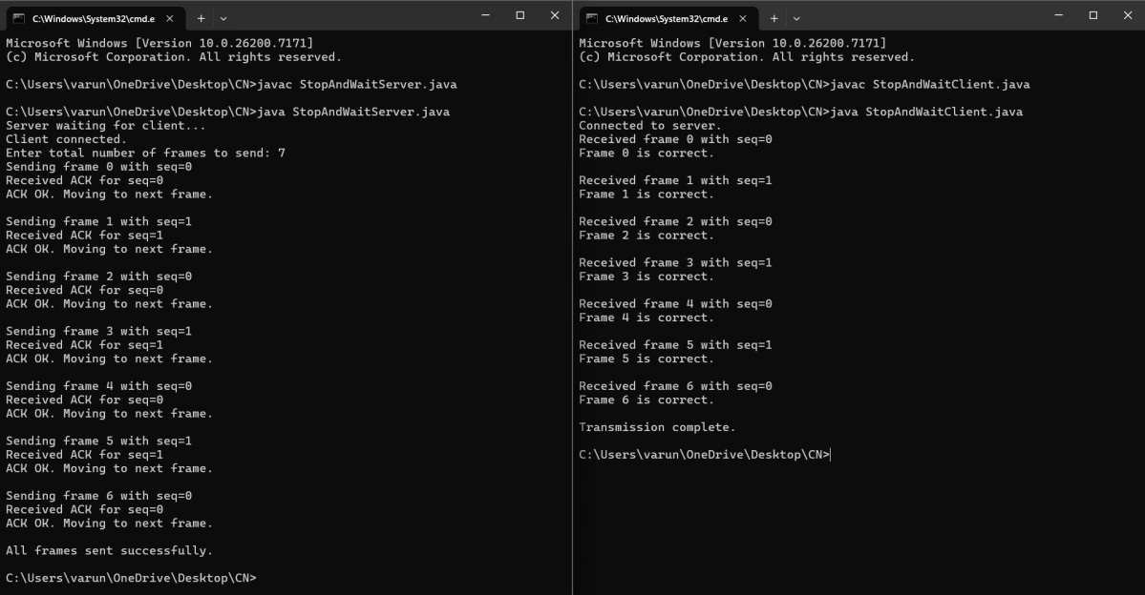
2.
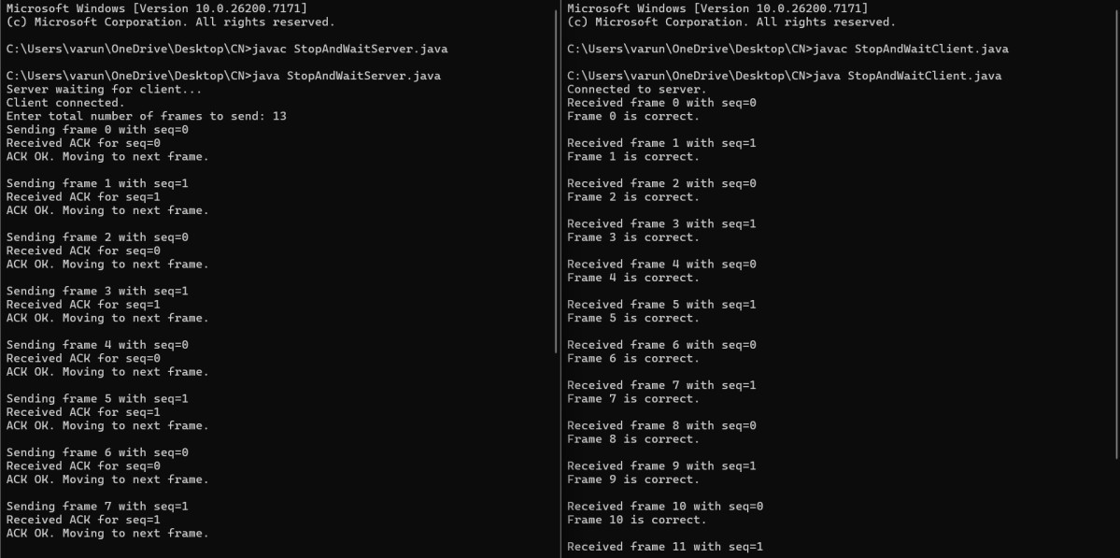
3.
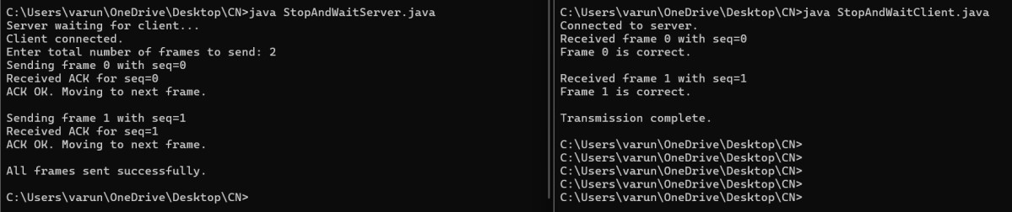

Experiment 5: Distance Vector Routing Protocol

Aim:
To implement the Distance Vector Routing algorithm.

About:
Each router maintains a routing table with the distance to every other node. Routers periodically exchange updates with their neighbors to optimize routes.

Code:
import java.io.*;
public class DVR
{
static int graph[][]; static int via[][]; static int rt[][]; static int v;
static int e;
public static void main(String args[]) throws IOException
{
BufferedReader br = new BufferedReader(new InputStreamReader(System.in));

System.out.println("Please enter the number of Vertices: "); v = Integer.parseInt(br.readLine());

System.out.println("Please enter the number of Edges: "); e = Integer.parseInt(br.readLine());
graph = new int[v][v]; via = new int[v][v]; rt = new int[v][v];
for(int i = 0; i < v; i++)
for(int j = 0; j < v; j++)
{
if(i == j) graph[i][j] = 0; else
graph[i][j] = 9999;
}

for(int i = 0; i < e; i++)
{
System.out.println("Please enter data for Edge " + (i + 1) + ":"); System.out.print("Source: ");
int s = Integer.parseInt(br.readLine()); s--;
System.out.print("Destination: ");
int d = Integer.parseInt(br.readLine()); d--;
System.out.print("Cost: ");
int c = Integer.parseInt(br.readLine()); graph[s][d] = c;
graph[d][s] = c;
}

dvr_calc_disp("The initial Routing Tables are: ");

System.out.print("Please enter the Source Node for the edge whose cost has changed: ");

int s = Integer.parseInt(br.readLine()); s--;
System.out.print("Please enter the Destination Node for the edge whose cost has changed: ");
int d = Integer.parseInt(br.readLine()); d--;
System.out.print("Please enter the new cost: "); int c = Integer.parseInt(br.readLine()); graph[s][d] = c;
graph[d][s] = c;

dvr_calc_disp("The new Routing Tables are: ");
}

static void dvr_calc_disp(String message)
{
System.out.println(); init_tables(); update_tables(); System.out.println(message); print_tables(); System.out.println();
}
static void update_table(int source)
{
for(int i = 0; i < v; i++)
{
if(graph[source][i] != 9999)
{
int dist = graph[source][i];
for(int j = 0; j < v; j++)
{
int inter_dist = rt[i][j]; if(via[i][j] == source) inter_dist = 9999;
if(dist + inter_dist < rt[source][j])
{
rt[source][j] = dist + inter_dist; via[source][j] = i;
}
}
}
}
}

static void update_tables()
{
int k = 0;
for(int i = 0; i < 4*v; i++)
{
update_table(k); k++;
if(k == v) k = 0;
}
}
static void init_tables()
{
for(int i = 0; i < v; i++)
{
for(int j = 0; j < v; j++)
{
if(i == j)

{
rt[i][j] = 0;
via[i][j] = i;
}
else
{
rt[i][j] = 9999;
via[i][j] = 100;
}
}
}
}

static void print_tables()
{
for(int i = 0; i < v; i++)
{
for(int j = 0; j < v; j++)
{
System.out.print("Dist: " + rt[i][j] + " ");
}
System.out.println();
}
}
}

Output:
1.

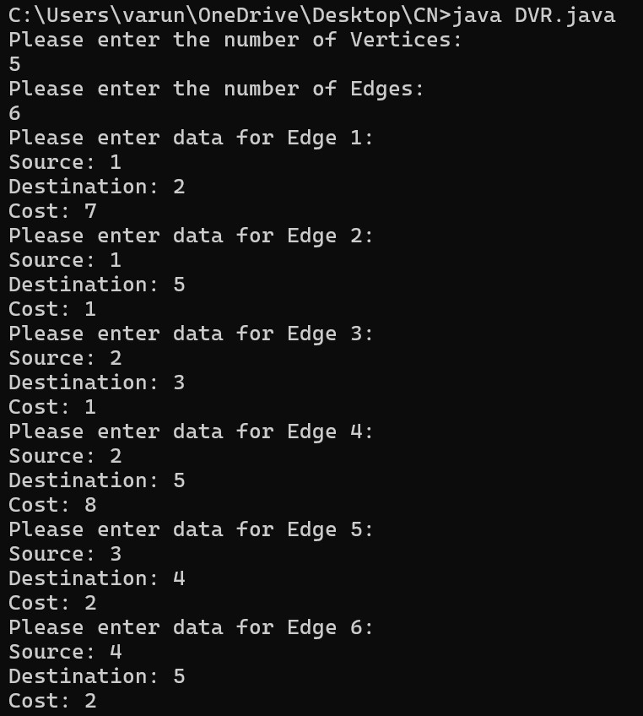
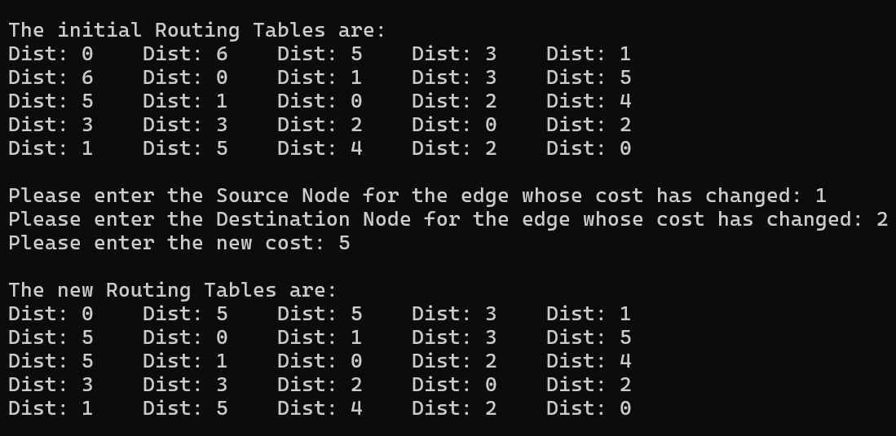

2.
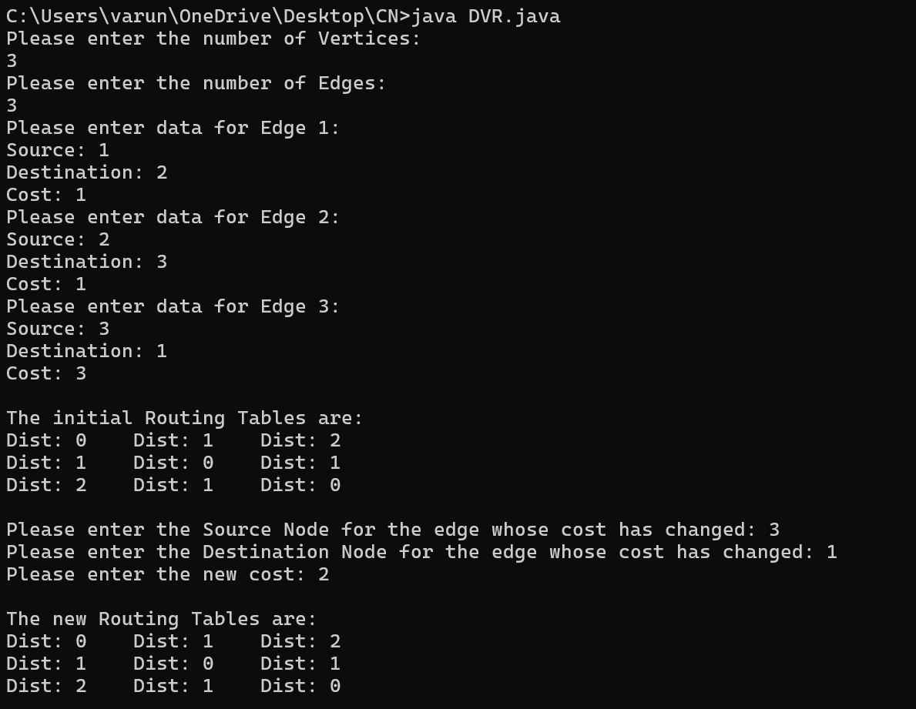
3.
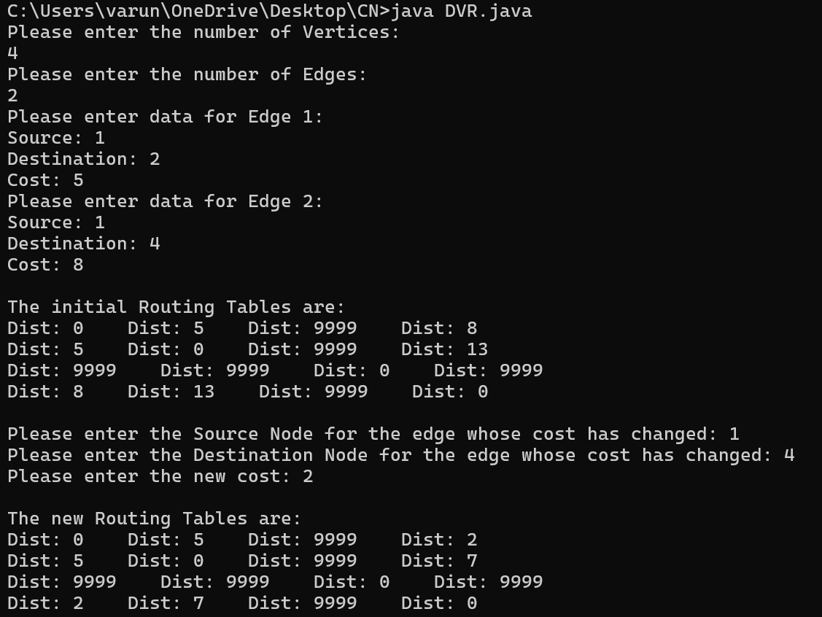

Experiment 6: Echo Command in Socket Programming

Aim:
To implement an echo command using client-server socket programming.

About:
In the echo program, the client sends a message to the server, and the server responds with the same message. It demonstrates basic socket communication.

Code:
echoServer
import java.io.*;
import java.net.*;

public class EchoServer {
public static void main(String[] args) {
int port = 12345; // You can choose any available port number
try (ServerSocket serverSocket = new ServerSocket(port)) { System.out.println("Echo Server is running on port " + port);

while (true) {
Socket clientSocket = serverSocket.accept(); // Accept a connection System.out.println("Client connected: " + clientSocket.getInetAddress());

// Create input and output streams for communication BufferedReader in = new BufferedReader(new
InputStreamReader(clientSocket.getInputStream()));
PrintWriter out = new PrintWriter(clientSocket.getOutputStream(), true);
String line;
while ((line = in.readLine()) != null) { System.out.println("Received from client: " + line); out.println(line); // Echo the message back to the client
}

System.out.println("Client disconnected."); clientSocket.close();
}
} catch (IOException e) {
System.err.println("Server exception: " + e.getMessage()); e.printStackTrace();
}
}
}

echoClient
import java.io.*;
import java.net.*;

public class EchoClient {
public static void main(String[] args) {
String hostname = "localhost"; // or the server's IP address
int port = 12345;

try (Socket socket = new Socket(hostname, port)) { System.out.println("Connected to server");

// Input from user
BufferedReader userInput = new BufferedReader(new InputStreamReader(System.in));

// Streams for communication with server
PrintWriter out = new PrintWriter(socket.getOutputStream(), true); BufferedReader in = new BufferedReader(new
InputStreamReader(socket.getInputStream()));

String message;
System.out.println("Type a message (type 'exit' to quit):");

while (true) { System.out.print("> ");
message = userInput.readLine();

if (message.equalsIgnoreCase("exit")) {
break;
}

out.println(message); // Send message to server
String response = in.readLine(); // Read echoed message System.out.println("Echo from server: " + response);
}

System.out.println("Disconnected from server.");
} catch (IOException e) {
System.err.println("Client exception: " + e.getMessage()); e.printStackTrace();
}
}
}

Output:
1.
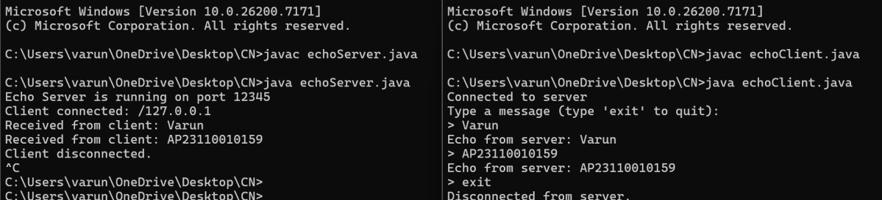
2.
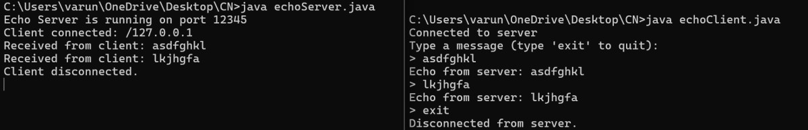
3.

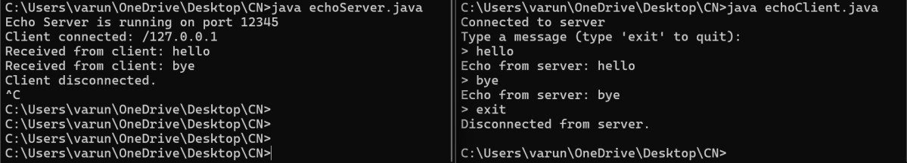

Experiment 7: Trace Route Command Simulation

Aim:
To simulate the functionality of the traceroute command.

About:
Traceroute identifies the route packets take to reach a destination by incrementally increasing the Time-to-Live (TTL) value and recording intermediate hops.

Code:
import java.io.BufferedReader; import java.io.IOException; import java.io.InputStreamReader;
public class TraceRoute {

public static void main(String[] args) {
if (args.length != 1) {
System.out.println("Usage: java TraceRoute <hostname>");
return;
}

String host = args[0]; String command;

// Detect OS
String os = System.getProperty("os.name").toLowerCase();

if (os.contains("win")) {
command = "tracert " + host; // Windows command
} else {
command = "traceroute " + host; // Linux / Mac command
}

System.out.println("Running: " + command + "\n");

try {
Process process = Runtime.getRuntime().exec(command);

BufferedReader input = new BufferedReader(
new InputStreamReader(process.getInputStream())
);

String line;
while ((line = input.readLine()) != null) { System.out.println(line);
}

input.close();

} catch (IOException e) {
System.out.println("Error running traceroute: " + e.getMessage());
}
}
}
Output:
1.

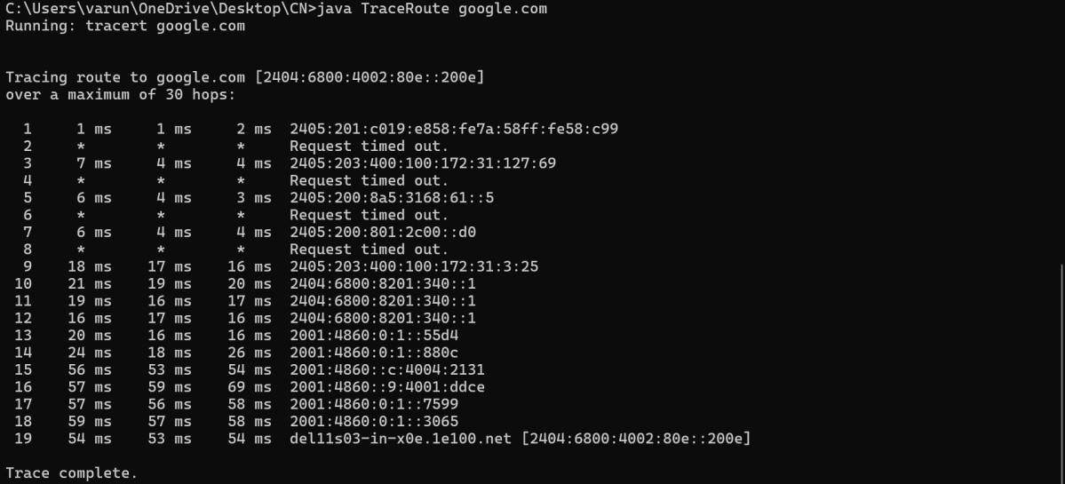
2.
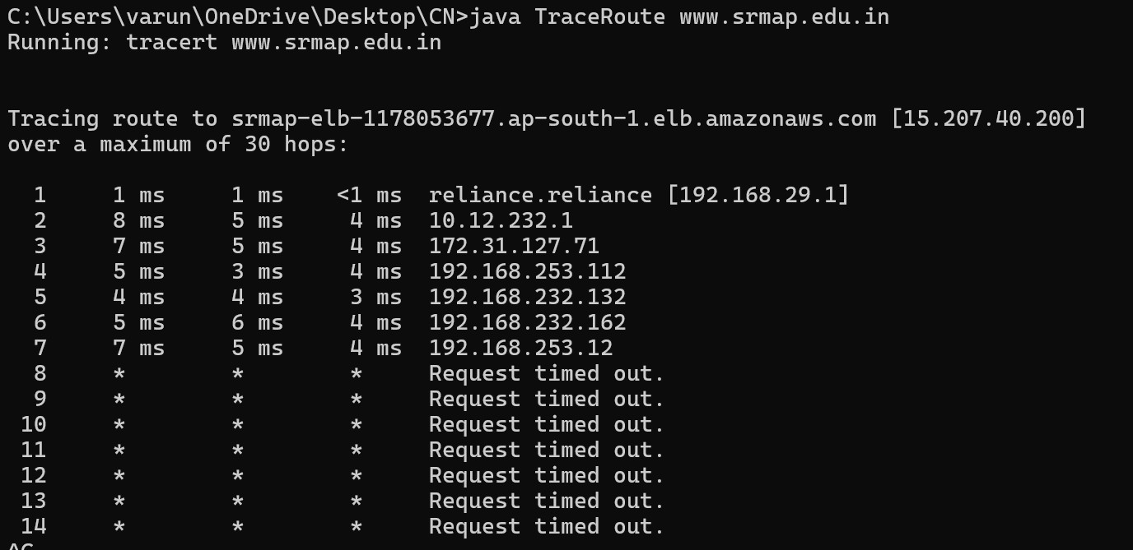
3.

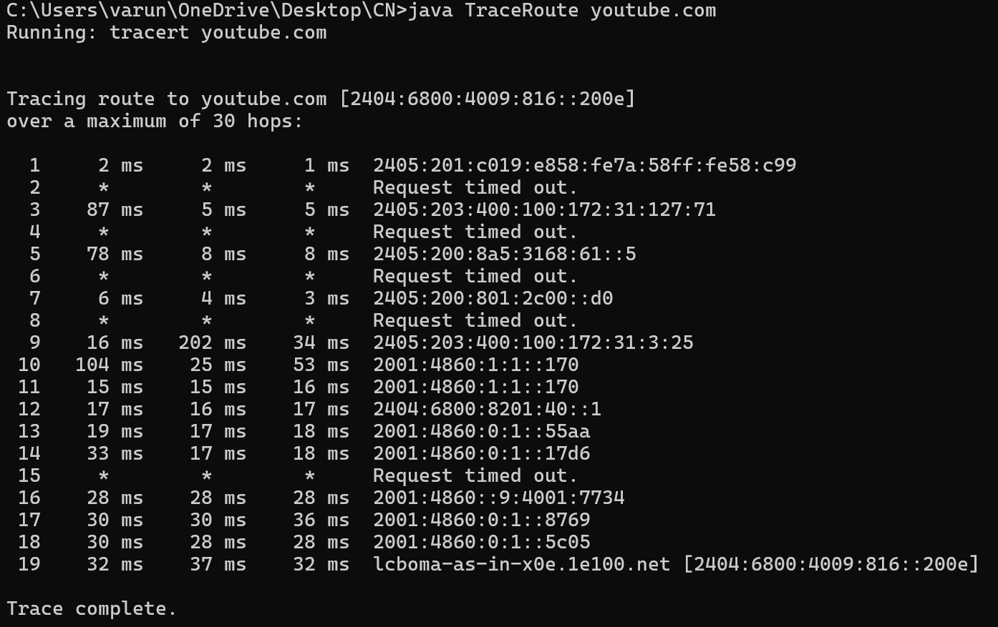

Experiment 8: Ping Command Implementation

Aim:
To demonstrate the working of the Ping command.

About:
Ping tests connectivity between two network devices by sending ICMP Echo Request messages and measuring the time taken for Echo Replies.

Code:
import java.io.IOException;
import java.net.InetAddress;
public class PingSimulator {
public static void main(String[] args) {
if (args.length != 1) {
System.out.println("Usage: java PingSimulator <hostname>");
return;
}

String host = args[0];
int pingCount = 4;
int timeout = 1000; // milliseconds

try {
InetAddress inet = InetAddress.getByName(host);
System.out.println("Pinging " + host + " with " + timeout + "ms timeout:");

for (int i = 1; i <= pingCount; i++) {
long startTime = System.currentTimeMillis(); boolean reachable = inet.isReachable(timeout); long endTime = System.currentTimeMillis(); long rtt = endTime - startTime;
if (reachable) {
System.out.println("Reply from " + inet.getHostAddress() + ": time=" +
rtt + "ms");
} else {
System.out.println("Request timed out.");
}

Thread.sleep(1000); // Wait 1 second between pings
}

System.out.println("Ping simulation complete.");
} catch (IOException e) {
System.out.println("I/O error: " + e.getMessage());
} catch (InterruptedException e) { System.out.println("Ping interrupted.");
}
}
}

Output:
1.
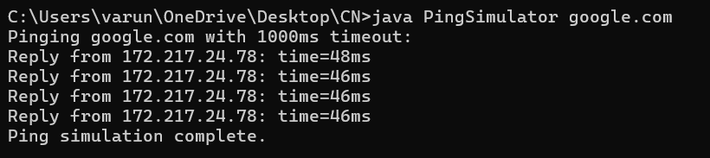
2.
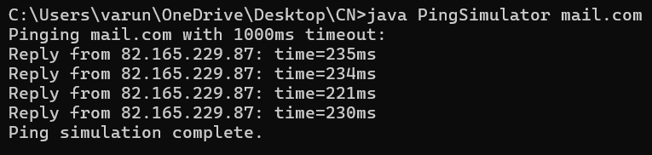

3.
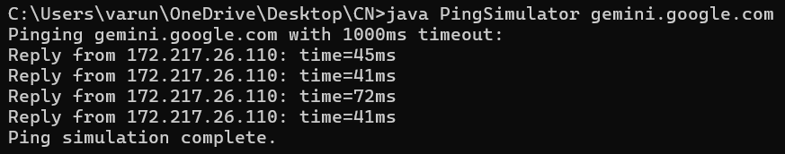

Experiment 9-: IP Address Classification and Subnet Generation

Aim:
To write a program to display the IP class, network mask, and generate subnet IPs based on user input.

About:
This program helps understand IP addressing, subnetting, and network segmentation by analyzing entered IP and subnet bits.

Code:
IPSubnetCalculator.java
import java.util.Scanner;

public class IPSubnetCalculator {

// Determine the class of the IP address
private static String getIPAddressClass(String ip) {
int firstOctet = Integer.parseInt(ip.split("\\.")[0]);

if (firstOctet >= 1 && firstOctet <= 126) {
return "A";
} else if (firstOctet >= 128 && firstOctet <= 191) {
return "B";
} else if (firstOctet >= 192 && firstOctet <= 223) {
return "C";
} else if (firstOctet >= 224 && firstOctet <= 239) {
return "D (Multicast)";
} else if (firstOctet >= 240 && firstOctet <= 255) {
return "E (Experimental)";
} else {
return "Invalid";
}
}

// Get default subnet mask based on class
private static String getDefaultSubnetMask(String ipClass) {
switch (ipClass) {
case "A":
return "255.0.0.0";
case "B":
return "255.255.0.0";
case "C":
return "255.255.255.0";
default:
return "Not applicable";
}
}

// Convert decimal mask to binary string
private static String convertMaskToBinary(int maskBits) { StringBuilder mask = new StringBuilder();
for (int i = 0; i < 32; i++) {
if (i < maskBits) { mask.append("1");
} else {
mask.append("0");

}
if ((i + 1) % 8 == 0 && i != 31) {
mask.append(".");
}
}
return mask.toString();
}
// Generate subnet mask from subnet bits
private static String generateSubnetMask(int subnetBits) { String binaryMask = convertMaskToBinary(subnetBits); String[] octets = binaryMask.split("\\."); StringBuilder mask = new StringBuilder();

for (int i = 0; i < 4; i++) {
int value = Integer.parseInt(octets[i], 2); mask.append(value);
if (i < 3) {
mask.append(".");
}
}
return mask.toString();
}
// Calculate subnet address
private static String calculateSubnetAddress(String ip, String subnetMask) { String[] ipOctets = ip.split("\\.");
String[] maskOctets = subnetMask.split("\\."); StringBuilder subnetAddress = new StringBuilder();

for (int i = 0; i < 4; i++) {
int ipPart = Integer.parseInt(ipOctets[i]);
int maskPart = Integer.parseInt(maskOctets[i]); int subnetPart = ipPart & maskPart; subnetAddress.append(subnetPart);
if (i < 3) {
subnetAddress.append(".");
}
}
return subnetAddress.toString();
}

public static void main(String[] args) { Scanner scanner = new Scanner(System.in);

System.out.print("Enter IP Address (e.g., 192.168.1.1): "); String ip = scanner.nextLine();

String ipClass = getIPAddressClass(ip); System.out.println("IP Address Class: " + ipClass);

String defaultMask = getDefaultSubnetMask(ipClass); System.out.println("Default Network Mask: " + defaultMask);

System.out.print("Enter subnet bits (e.g., 24): ");
int subnetBits = scanner.nextInt();
if (subnetBits < 0 || subnetBits > 32) { System.out.println("Invalid subnet bits."); return;
}

String subnetMask = generateSubnetMask(subnetBits); System.out.println("Subnet Mask: " + subnetMask);

String subnetAddress = calculateSubnetAddress(ip, subnetMask); System.out.println("Subnet Address: " + subnetAddress);

scanner.close();
}
}

Output:
1.
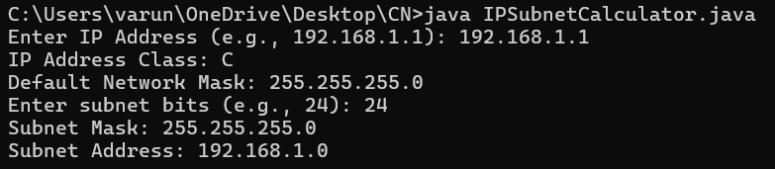
2.
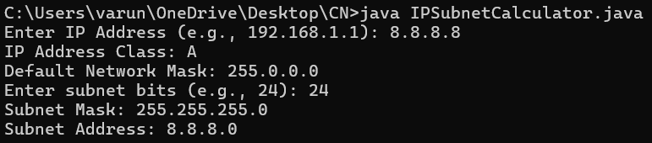
3.
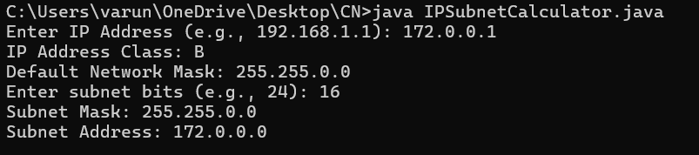

Experiment 10: Dijkstra’s Shortest Path Routing Protocol

Aim:
To implement Dijkstra’s algorithm to find the shortest path between nodes in a network.

About:
Dijkstra’s algorithm determines the shortest path in a graph by iteratively selecting the
minimum distance vertex. It is widely used in routing protocols like OSPF.

Code:
import java.util.*;

public class DijkstraShortestPath {

public static void dijkstra(int source, int n, List<List<int[]>> adj) {
int[] dist = new int[n + 1]; Arrays.fill(dist, Integer.MAX_VALUE); dist[source] = 0;

PriorityQueue<int[]> pq = new PriorityQueue<>(Comparator.comparingInt(a -> a[0])); pq.offer(new int[]{0, source}); // {distance, node}
while (!pq.isEmpty()) {
int[] top = pq.poll(); int currentDist = top[0]; int node = top[1];

if (currentDist > dist[node])
continue;

for (int[] edge : adj.get(node)) {
int nextNode = edge[0];
int weight = edge[1];

if (dist[node] + weight < dist[nextNode]) { dist[nextNode] = dist[node] + weight; pq.offer(new int[]{dist[nextNode], nextNode});
}
}
}

System.out.println("Shortest distances from source " + source + ":");
for (int i = 1; i <= n; i++) { System.out.println("Node " + i + " -> " + dist[i]);
}
}

public static void main(String[] args) { Scanner sc = new Scanner(System.in);

System.out.print("Enter number of nodes and edges: ");
int n = sc.nextInt();
int m = sc.nextInt();

List<List<int[]>> adj = new ArrayList<>();

for (int i = 0; i <= n; i++) adj.add(new ArrayList<>());

System.out.println("Enter edges (u v w):");
for (int i = 0; i < m; i++) {
int u = sc.nextInt(); int v = sc.nextInt(); int w = sc.nextInt();
adj.get(u).add(new int[]{v, w});
}

System.out.print("Enter source node: ");
int source = sc.nextInt();

dijkstra(source, n, adj);
}
}
Output:
1.
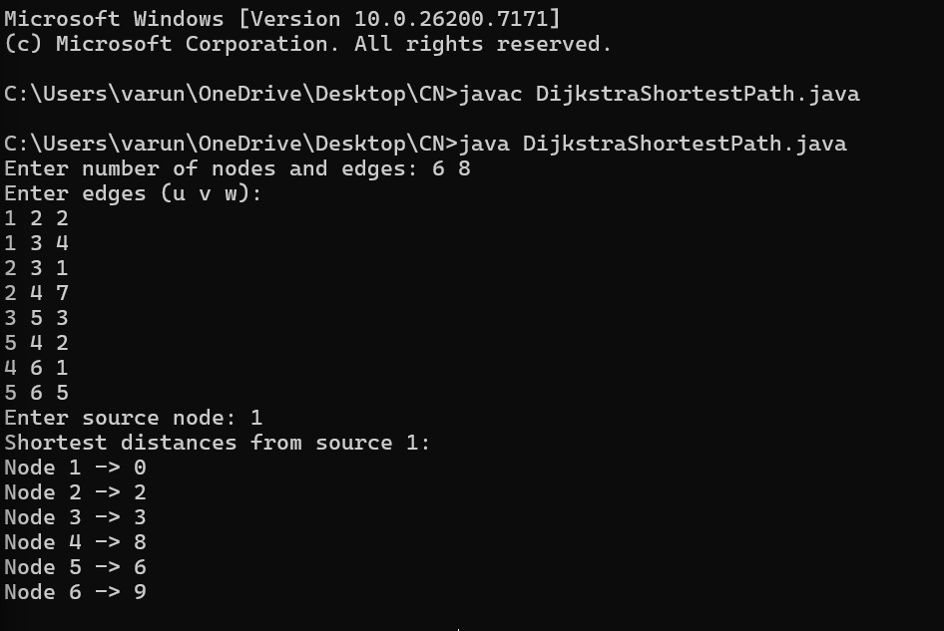
2.

